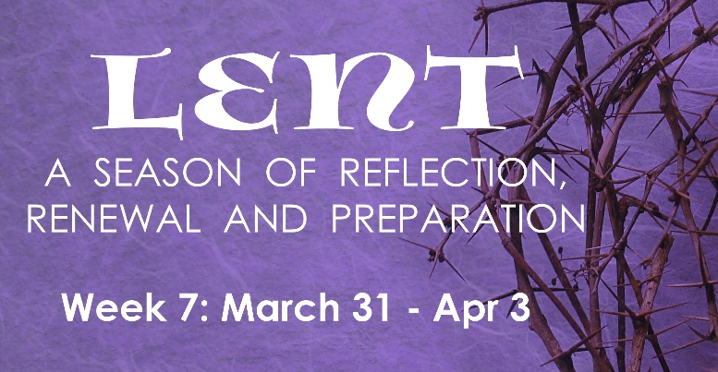
PRAYER
Almighty God, your Son our Savior suffered at human hands and endured the shame of the cross. Grant that we may walk in the way of his cross and find it the way of life and peace, through Jesus Christ, our Savior and Lord, who lives and reigns with you and the Holy Spirit, one God, now and forever. Amen.

INSTRUCTIONS: First, do the “Reading & Reflection” for the day, then pick at least two activities assigned for the day.

# | Date | Reading & Reflection  - What do you hear?  - How does it make you feel?  - Toward what are you being drawn?  - What do you sense are you being urged to do? | Activity
43 | Wed, Mar 31 | Hebrews 12:1-2 - “Therefore, since we are surrounded by so great a cloud of witnesses, let us also lay aside every weight and the sin that clings so closely, and let us run with perseverance the race that is set before us, looking to Jesus the pioneer and perfecter of our faith, who for the sake of the joy that was set before him endured the cross, disregarding its shame, and has taken his seat at the right hand of the throne of God. |  Go to confession   Do something for nice someone who is going through a difficult time: call, text, send a card or flowers, etc.   Give up buying yourself a treat this week. Donate the money to charity or buy something for someone in need.   Fast. Eat only 1 full meal and have only bread and water for the other meals.
44 | Thurs, April 1 | 1 Corinthians 11:23-26 - “For I received from the Lord what I also handed on to you, that the Lord Jesus on the night when he was betrayed took a loaf of bread, and when he had given thanks, he broke it and said, “This is my body that is for you. Do this in remembrance of me.” In the same way he took the cup also, after supper, saying, “This cup is the new covenant in my blood. Do this, as often as you drink it, in remembrance of me.” For as often as you eat this bread and drink the cup, you proclaim the Lord’s death until he comes.” |  Holy Thursday: Attend Mass  - Watch “Search” in FORMED: Ep 7: Why A Church  https://watch.formed.org/videos/thesearch-ep7   Attend SEARCH ep. 7 group discussion via Zoom at 6:00-7:00 PM  Meeting ID: 889 4320 4246  Password: SEARCH   Contribute at least $10 to some charity that provides food or lodging for the poor.
45 | Fri, April 2 | Isaiah 53:4 – “Surely he has borne our infirmities and carried our diseases; yet we accounted him stricken, struck down by God, and afflicted. But he was wounded for our transgressions, crushed for our iniquities; upon him was the punishment that made us whole, and by his bruises we are healed.” |  Look at a crucifix and meditate on Christ’s passion, reflect on the intense suffering Christ accepted although He was God.  - Pray the Stations of the Cross   Pray the Sorrowful Mysteries of the Rosary   Attend Mass
46 | Sat, April 3 | Mark 16:6 – ‘He has been raised; he is not here!” |  Attend Lectio Divina via Zoom: 10:00 AM-10:30AM  Meeting ID: 865 1572 1949 Passcode: LECTIO2   Attend Mass   Reflect on your Lenten journey. Think about how you can continue to grow throughout the Easter season.

Easter Sunday, April 4

Enjoy this day the Lord has made. Let the risen Jesus be with you and your family. Feel the joy of Jesus’ resurrection and life within you. Celebrate his love all the days of your life. Christ is risen. Alleluia! Alleluia!

Happy and blessed Easter! God bless you and your beautiful family.

