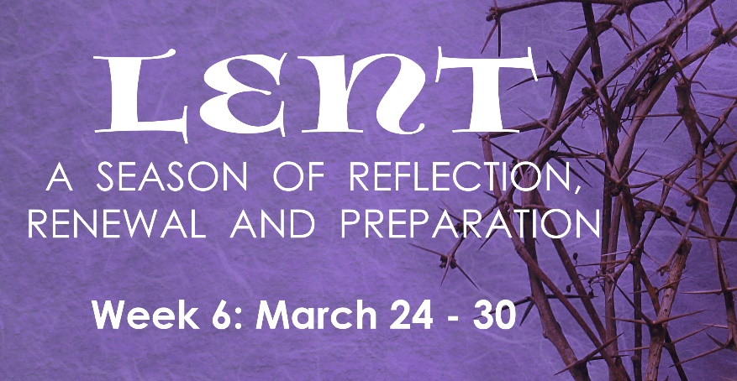
PRAYER
Generous, compassionate, empathetic God, you alone created, redeemed me to live in the Spirit. Give me continual strength and guidance to seek your loving Spirit in me. Help me to commune with you through acts of compassion, empathy, and generosity. In the name of your Son, Jesus Christ our Lord, Amen.

INSTRUCTIONS: Do the “Reading & Reflection” for the day, then pick at least two activities assigned for the day.
# | Date | Reading & Reflection  - What do you hear?  - How does it make you feel?  - Toward what are you being drawn?  - What do you sense are you being urged to do? | Activity
36 | Wed, Mar 24 | John 8:32 – “If you remain in my word, you will truly be my disciples, and you will know the truth, and the truth will set you free.” | - Thank someone from your past who made a difference in your life  - Pray for vocations to women’s religious congregations  - Compliment at least one person today  - Say a prayer for persons you pass by and ask God to bless them
37 | Thurs, Mar 25 | Isaiah 7:14 – “Therefore the Lord himself will give you this sign: the virgin shall be with child, and bear a son, and shall name him Emmanuel, which means ‘God is with us!’” | - Watch “Search” in FORMED: Ep 6: Am I Saved  https://watch.formed.org/videos/thesearch-ep6  - Attend SEARCH Ep. 6: “Am I Saved” Group discussion  via Zoom at 6:00-7:00 PM  Meeting ID: 889 4320 4246 Password: SEARCH  - Feast of the Annunciation: Say the “Angelus” at 12noon  - Attend Mass
38 | Fri, Mar 26 | John 10:32 – “I have shown you many good works from my Father. For which of these are you trying to stone me?” | - Fast. Abstain from meat and alcoholic beverage  - Read Chapter 10 of St. John’s Gospel  - Say a decade of the rosary for persecuted Christians around the world
39 | Sat, Mar 27 | John 11:48– “If we leave him alone, all will believe in him, and the Romans will come and take away both our land and our nation.” | - Attend Lectio Divina via Zoom: 10:00 AM-10:30AM  Meeting ID: 865 1572 1949  Passcode: LECTIO2  - Look at a crucifix and meditate on Christ’s passion, reflect on the intense suffering he accepted.  - Read the “Beatitudes” to be inspired toward humility and service
40 | Sun, Mar 28 | Mark 14:22 – “Take it; this is my body.” | - Palm Sunday: Bring the entire family to Mass  - Pray for bishops, priests, seminarians and deacons  - Arrive 15 mins early at Mass to pray quietly  - Donate some canned good to the Parish Pantry or Food bank
41 | Mon, Mar 29 | John 12:8 – “You always have the poor with you, but you do not always have me.” | - Pray for the poor souls in purgatory  - Say one decade of the rosary that the Supreme Court protects life and religious freedom  - Do a good deed in secret without expecting recognition  - Thank someone from your past who made a difference in your life  - Resist looking at your phone when you are with others
42 | Tues, Mar 30 | John 13:21 – “Amen, amen, I say to you, one of you will betray me.” | - Abstain from complaining about anybody or anything  - Pray for the sick in your family or parish  - Go to Confession  - Resist looking at your phone when you are with others

