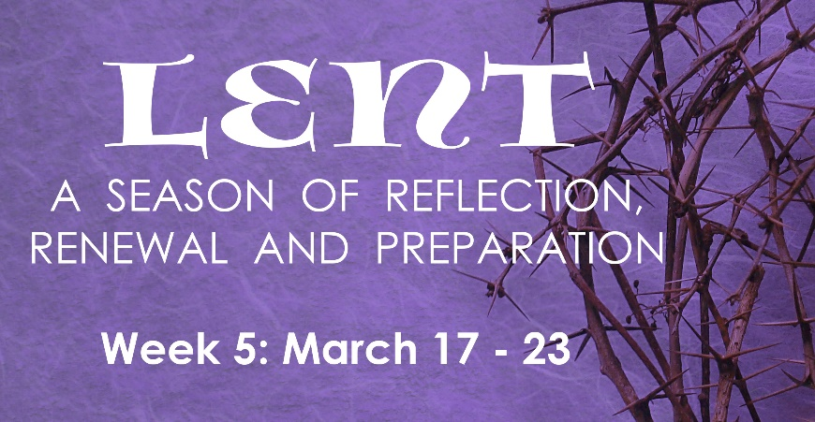
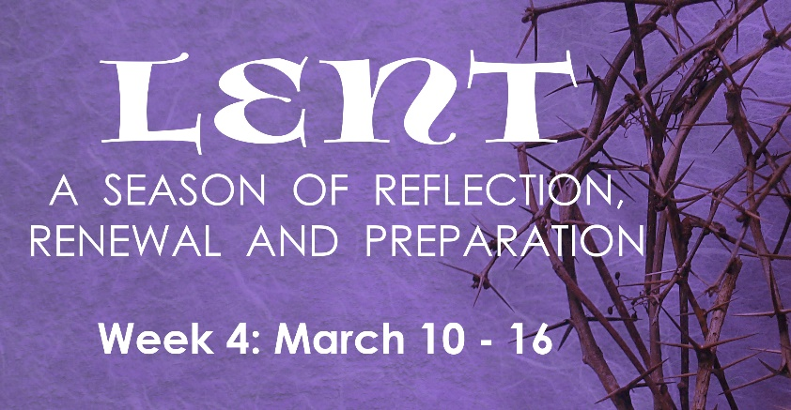
PRAYER
Lord, bless our home and family. Make us one, Lord.
Bless all those who enter here. Make us one, Lord.
Bless our family wherever they are, (especially…). Make us one Lord.
Bless all of your children, all of our brothers and sisters around the word. Make us one, Lord.

INSTRUCTIONS: Do the “Reading & Reflection” for the day, then pick at least two activities assigned for the day.

# | Date | Reading & Reflection  - What do you hear?  - How does it make you feel?  - Toward what are you being drawn?  - What do you sense are you being urged to do? | Activity
29 | Wed, Mar 17 | John 5:24 – “Anyone who hears and believes…has eternal life.” | - Pray for the poor souls in purgatory  - Do a good deed in secret, without expecting recognition  - Compliment at least one person today  - Say a prayer for persons you pass by and ask God to bless them
30 | Thurs, Mar 18 | Exodus 32:8 – “They have soon turned aside from the way I pointed out to them, making for themselves a molten calf.” | - Watch “Search” in FORMED: Ep 5: Who Is Jesus?  https://watch.formed.org/the-search/videos/thesearch-ep5  - Attend SEARCH Ep. 5: “Who Is Jesus” Group discussion  via Zoom at 6:00-7:00 PM  Meeting ID: 889 4320 4246 Password: SEARCH  - Read the Beatitudes, be inspired toward humility & service  - Look at a crucifix and meditate on Christ’s passion
31 | Fri, Mar 19 | Matthew 1:20 – “Have no fear about taking Mary as your wife.” | - Fast. Abstain from meat and eat only one full meal and have only bread and water for the other meals  - St. Joseph’s Day – bake St. Joseph buns for the family  - Thank someone from your past who made a difference in your life
32 | Sat, Mar 20 | John 7:43– “So a division occurred in the crowd because of him.”.” | - Attend Lectio Divina via Zoom: 10:00 AM-10:30AM  Meeting ID: 865 1572 1949  Passcode: LECTIO2  - First day of spring…buy a potted plant or cut flowers to remind you that Jesus has launched a new creation  - Volunteer to do someone else’s chore
33 | Sun, Mar 21 | Jeremiah 31:33 – “I will place my law within them and write it upon their hearts.” | - Pray for bishops, priests, seminarians and deacons  - Arrive 15 mins early at Mass to pray quietly  - Evangelize by thanking someone with a promise to pray for that person. But be sure to do it!
34 | Mon, Mar 22 | John 12:30 – “Jesus answered and said, ‘This voice did not come for my sake but for yours.’” | - Look at a crucifix and meditate on Christ’s passion  - Say one decade of the rosary that the Supreme Court protects life and religious freedom  - Abstain from complaining about anyone or anything all day
35 | Tues, Mar 23 | John 8:23– “You belong to what is below, I belong to what is above. You belong to this world, but I do not belong to this world.” | - Thank God for five things before 8 am today.  - Pray for young people in your parish who are “nones.”  - Do at least one random act of kindness  - Pray for the souls in purgatory

