PRAYER
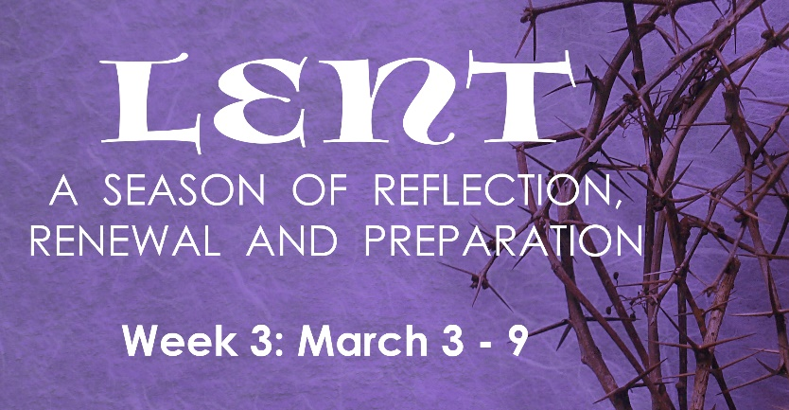
Almighty and merciful God, in your goodness keep us, we pray, from all things that may hurt us, that we, being ready both in mind and body, may accomplish with free hearts those things which belong to your purpose; through Jesus Christ our Lord, who lives and reigns with you and the Holy Spirit, one God, now and forever. Amen

INSTRUCTIONS: Do the “Reading & Reflection” for the day, then pick at least two activities assigned for the day.

# | Date | Reading & Reflection  - What do you hear?  - How does it make you feel?  - Toward what are you being drawn?  - What do you sense are you being urged to do? | Activity
15 | Wed, Mar 3 | Jer 18:18– “Let us destroy him by his own tongue; let us carefully note his every word.” | - Fast from gossiping, saying unkind words  - Pray for someone you have hurt in the past  - Go to Confession
16 | Thurs, Mar 4 | Luke 16:25– “Abraham replied, ‘My child, remember that you received what was good during your lifetime while Lazarus likewise received what was bad.” | - Watch “Search” in FORMED: Ep 3: Why A God  https://watch.formed.org/videos/thesearch-ep3  - Attend SEARCH Ep. 3 Group discussion  via Zoom at 6:00-7:00 PM  Meeting ID: 889 4320 4246 Password: SEARCH  - List 5 things you are grateful for, and thank God for them  - Do one corporal work of mercy: feed the hungry, visit the sick or make a charitable donation
17 | Fri, Mar 5 | Matthew 21;43 – “Therefore, I say to you, the Kingdom of God will be taken away from you and given to a people that will produce its fruit.” | - Invite a friend or relative to Adoration  - Pray the Stations of the Cross in church or at home  - Pray for a sick person in your family or parish and send a short note letting him/her know you are praying for him/her  - Eat only one full meal and abstain from meat
18 | Sat, Mar 6 | Mic 7:18 – “Who is there like you, the God who removes guilt and pardons sin for the remnant of his inheritance…?” | - Attend Lectio Divina via Zoom: 10:00 AM-10:30AM  Meeting ID: 865 1572 1949  Passcode: LECTIO2  - Go to confession. Prayerfully ask God’s forgiveness, then let go of your burdens and hand it over to Him.  - Pray for the intentions and health of the Holy Father
19 | Sun, Mar 7 | Mark 9:2-3 – “And he was transfigured before them, and his clothes became dazzling white, such as no fuller on earth could bleach them.” | - Dress up for Sunday Mass  - Arrive at Mass 15 mins early to pray quietly  - Pray the Rosary with the family
20 | Mon, Mar 8 | Kings 5:13 – “”But his servants came up and reasoned with him, ‘My father,’ they said, ‘if the prophet had told you to do something extraordinary, would you not have done it?’ | - Pray the Liturgy of the Hours  - Pray for someone who has left the Church  - Read Chapter 10 of St. Mark’s Gospel  - Watch a video that will enrich your spiritual life such as: Jesus of Nazareth, The Scarlet and the Black, The Passion of Christ
21 | Tues, Mar 9 | Matthew 18:21 – “Lord, if my brother sins against me, how often must I forgive him” As many as seven times?” | - Pray for someone who has hurt you in the past  - Pray for Catholic unity, that there would be one flock and one shepherd  - Pray for all the bishops of the Catholic Church  - Do at least one random act of kindness

