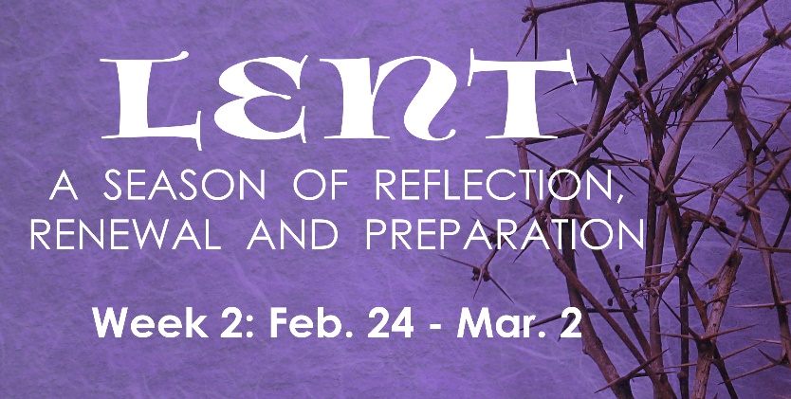
PRAYER
Merciful God, we thank you for your generosity and your compassion. We promise to do our part to be a force of good in the world. Be our light in the darkness. Amen.

INSTRUCTIONS: Do the “Reading & Reflection” for the day, then pick at least two activities assigned for the day.

# | Date | Reading & Reflection  - What do you hear?  - How does it make you feel?  - Toward what are you being drawn?  - What do you sense are you being urged to do? | Activity
8 | Wed, Feb 24 | Luke 11:32 – “At the judgement the men of Nineveh will arise with this generation and condemn it, because at the preaching of Jonah they repented and there is something greater than Jonah here.” | - Send a “Thinking of You” card to a distant relative or friend  - Spend one hour away from all technology  - Abstain from eating meat and non-nutritious snacks  - Bring a friend or a loved one to Adoration  - Smile or say “hello” to a stranger on the street
9 | Thurs, Feb 25 | Matthew 7:7-8, 12 – “Ask and it will be given to you; seek and you will find; knock and the door will be opened to you. For everyone who asks, receives, and the one who seeks finds; and the one who knocks, the door will be opened. Do to others whatever you would have them do to you.” | - Watch “Search” in FORMED: Ep 2: Who Are You  https://watch.formed.org/the-search-1/season:1/videos/thesearch-ep2  - Attend SEARCH Ep. 2 Group discussion  via Zoom at 6:00-7:00 PM  Meeting ID: 889 4320 4246 Password: SEARCH  - Pray for the millions of Christians suffering under persecution around the world.  - Make a conscious effort to offer this day to God
10 | Fri, Feb 26 | Matthew 5:23-24 – “If you bring your gift to the altar, and there recall that your brother has anything against you, leave your gift there at the altar, go first and be reconciled with your brother, and then come and offer your gift.” | - Fast. Abstain from meat (but do not feast on lobsters) and eat only one full meal and have only bread and water for the other meals  - Make the Stations of the Cross in church or at home  - Pray the Sorrowful Mysteries of the Rosary  - Pray for someone who has caused you pain in the past
11 | Sat, Feb 27 | Deut 26-18 – “And today the Lord is making this agreement with you; you are to be a people peculiarly his own, as he promised you.” | - Attend Lectio Divina via Zoom: 10:00 AM-10:30AM  Meeting ID: 865 1572 1949  Passcode: LECTIO2  - Create a care package and give it to the homeless  - Smile or say “hello” to a stranger on the street
12 | Sun, Feb 28 | Mark 9:2-3 – “And he was transfigured before them, and his clothes became dazzling white, such as no fuller on earth could bleach them.” | - Pray for priests, seminarians and deacons  - Leave a thoughtful note for someone  - Reflect over your life, list defining moments and how they transformed you.
13 | Mon, Mar 1 | Luke 6:36-38 – “Be merciful, just as your Father is merciful. Stop judging and you will not be judged. Stop condemning and you will not be condemned. Forgive and you will be forgiven. Give and gifts will be given to you. For the measure with which you measure will in return be measured out to you.” | - Smile and say hello to a stranger on the street  - List 5 people whom God has blessed you with and pray for them  - Donate money or food to someone in need
14 | Tues, Mar 2 | Matthew 23:11-12 – “The greatest among you must be your servant. Whoever exalts himself will be humbled; but whoever humbles himself will be exalted.” | - Spend at least 15 minutes with Jesus in Adoration  - Pray the Liturgy of the Hours  - Make and deliver a meal to a neighbor or friend  - Do at least one random act of kindness

